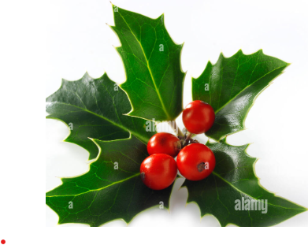CHRISTMAS LUNCH 2025
Soup | Jane
Soup | Marika
2 French sticks | Jeremy
1/2lb butter | Jeremy
2 lg bags crisps | Peter L
12 mince pies | Avis
12 mince pies | Elizabeth
Mixed crackers | Gordon
Stilton + brie | Gordon
Cheddar + camembert | Daniela
Red and green grapes | John Blakesley
Bag of apples + pears | Margaret
2 bags clementines | Chris A
Box of quality street
Sausage rolls | Chris T
Napkins | Elizabeth

